|  |  |
| --- | --- |
| **SQL** | **Mongo** |
| database/schema | database |
| table | collection |
| row | document |
| column | field |
| join | $lookup, embedded document |

* **Shell basic commands**

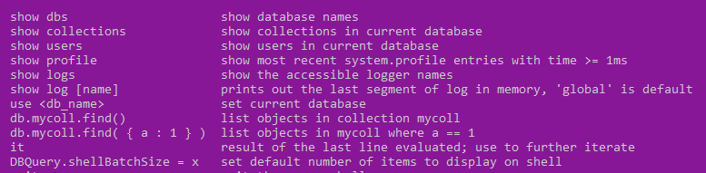

* **CRUD Operation**

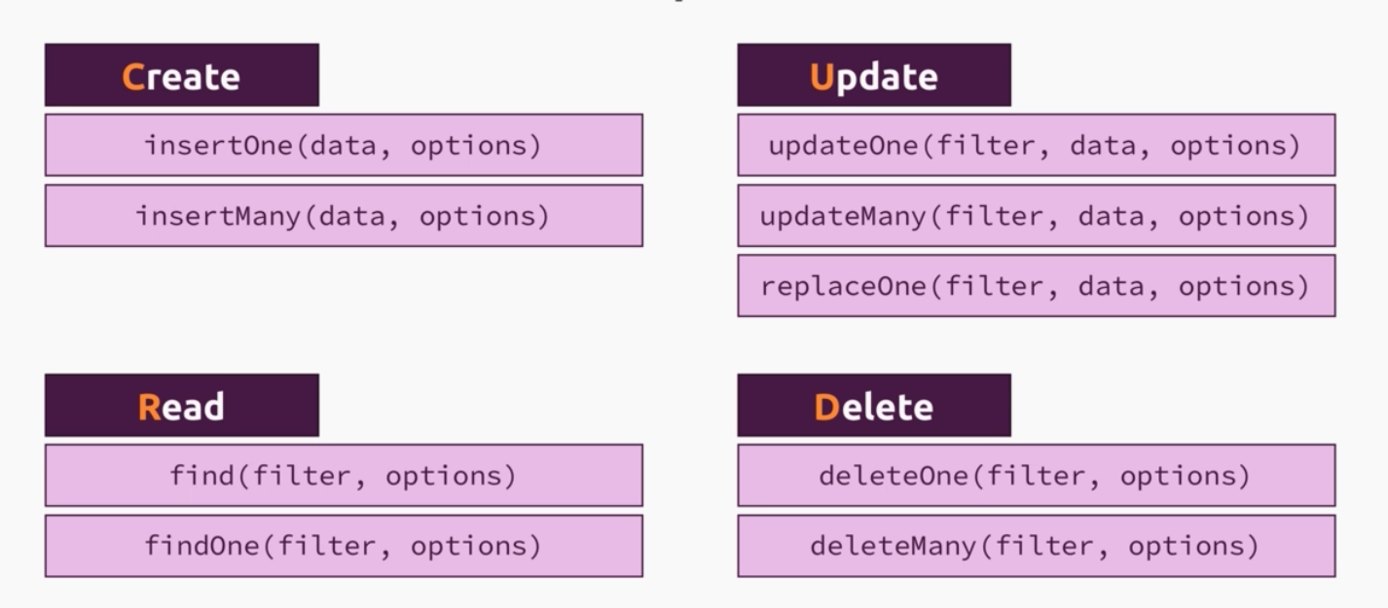

* **Mongo-DB data type**

<https://www.mongodb.com/docs/manual/reference/bson-types/>

Documents are key value pair, key being string. Value can be any valid BSon data type

* **Schema**

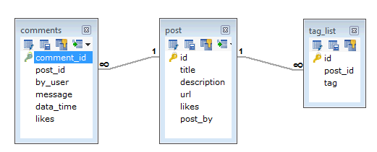

For this above SQL relation, a similar implementation can be following

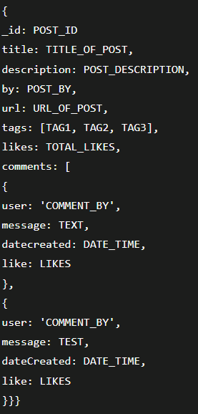

**Note**: Here is an issue, it is possible to have many duplicates for user and tags. In case we want to change something, we will need to make lot of changes. Instead, we can design it better by having separate comment and tag Collections, and in the post collection, we can store the _id of the comment and tag, instead of whole object.

* **Insert operation:**

Note: we can specify **_id** in the insert command if we want, otherwise mongo will generate its own unique id of type **ObjectId ()**

Insert a Single Document



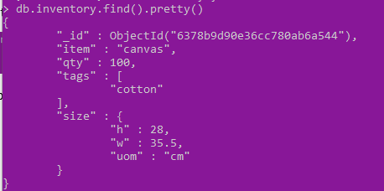

Insert Multiple Documents

